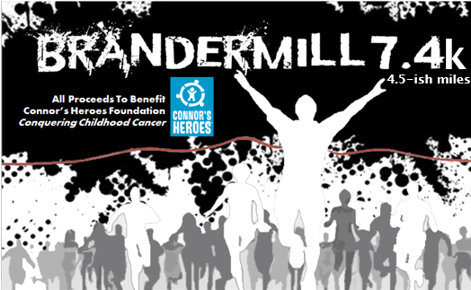
Dear Business Owner-
We cordially invite you to participate as a Sponsor of the 10th annual Brandermill 7.4k Race to be held on Sunday, July 4th at Clover Hill High School in Midlothian, VA. For the ninth year in a row, 100% of our race proceeds will go to the Connor’s Heroes Foundation, a local pediatric non-profit that provides assistance to children and their families while they are undergoing cancer treatments.
If you value giving back to our community, you don’t want to miss this opportunity to reach hundreds of local families and show your support for children who are battling cancer. With your help, we will reach our fundraising goal of $10,000. There are various levels of sponsorship for the Brandermill 7.4k Race. Size and placement of logos on T‐shirts and web site are based on sponsorship level.
Thank you in advance for your consideration of becoming a race sponsor. If you have any questions, please call Greg Epps at 804-909-2881 or email greg.epps@gmail.com. We look forward to this year’s event!
Sincerely,

Greg Epps, Race Director
greg.epps@gmail.com
Mobile: 804-909-2881

To learn more about Connor’s Heroes Foundation, please visit their website: https://www.connorsheroes.org
To learn more about the Brandermill 7.4k Race, please visit our website: http://www.brandermillrace.com

Sponsorship Levels
Gold Level Sponsor ‐ $1,000
- Large Company Logo printed on back of race T-shirt
- Promotional Materials in race packet
- Sponsorship Link on race website and social media
- Optional race day vendor booth on-site
- Special PA announcement mentioning sponsor name during and after the race
- 3 Complementary Race Entries

Silver Level Sponsor ‐ $500
- Small Company Logo printed on back of race T-shirt
- Sponsorship Link on race website and social media
- Optional race day vendor booth on-site
- 2 Complementary Race Entries
Water Station Sponsor - $150
- Company name / logo will appear on a prominently located sign at the water station, which is passed by the runners twice (there and back).

Brandermill 7.4k Race Sponsorship - July 4, 2021 at Clover Hill High School
Organization Name: _______________________________________________________________
Address: _________________________________________________________________________
City: ______________________________________________ State: _________ Zip: ____________
Contact person: ___________________________________________________________________
Contact email: _________________________ Phone number: _____________________
Web site address: _________________________________________________________________
- Sponsorship level (please circle):
Platinum Gold Silver Water Station
- We plan to send materials/giveaways for the participant bags: Yes No
If yes, what item would you like us to include: ________________________________________
- Sponsors can choose to have company name listed or submit a logo.
Please write your company name exactly how you’d like it to appear on web site, signage, etc.:
___________________________________________________________________
Artwork and logos should be submitted to brandermillrace@gmail.com as follows:
- Logos for T‐shirts will be printed only in one‐color and should be submitted as hi‐res (300 dpi) JPEG or EPS files. Most Photoshop and Illustrator files can also be accepted.
- Logos for signage should be submitted as hi‐res (300 dpi) JPEG or EPS files. Most Photoshop and Illustrator files can also be accepted.
- Logos for web site should be submitted as 72 dpi JPEG or PNG files.

- Participants can register for the Brandermill 7.4k Race at www.brandermillrace.com

- Sponsors can pay online (we’ll send an invoice) or checks can be made payable to Connor’s Heroes Foundation and mailed to: P.O. Box 2536, Midlothian, VA 23113. Please indicate “Brandermill Race” on the memo line.

